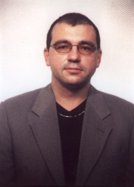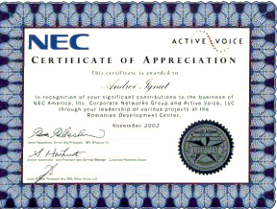

CURRICULUM VITAE IGNAT ANDREI FLORIN
E-mail: ignatandrei@yahoo.com
Tel: 0756.058.959
STUDIES:
I graduated the Master of Mathematics -promotion 1996
I graduated the Mathematics Faculty-promotion 1995
I graduated the Secondary School "I.L.Caragiale" Bucharest promotion 1989

Certifications :
- Microsoft Certified Professional (MCP) in VB6
(https://mcp.microsoft.com/authenticate/validatemcp.aspx : 684026 ;ignatandrei )

- MVP in C# for 2009, 2010, 2011 : https://mvp.support.microsoft.com/profile/Andrei.Ignat

Books :

  - Author and coordinator of “Baby Steps in VS2010 si .NET 4” : http://ronua.ro/CS/media/p/216886.aspx 1599 downloads

  - Author of “MVC tips and tricks e-book “: http://ronua.ro/CS/media/p/213920.aspx , 976 downloads

Blogs :

- Romanian Blog about programming , http://serviciipeweb.ro/iafblog/

- English Blog about programming , http://msprogrammer.serviciipeweb.ro/ . Mentioned on MSDN , http://msdn.microsoft.com/en-us/library/gg416514%28VS.98%29.aspx as an MVC resource blog.

Activity :

- Mathematics teacher for 7 years ( including during faculty)
- Programmer for 14 years : started with VB3 to VB6, ASP, ASP.NET and now MVC fan

